Electronics Circuits 2020/2

Fill in 3 fields below:

***[Student Number]***

***[Student Name, Surname]***

***[Group]* (Alper or Sercan)**

*Lab 1*

*09.04.2021*

*SAVE THIS FILE AS -> studentID_name_surname.pdf ; example= 5041562007_alper_eğitmen.pdf*

# Question No: 1:

a.) Draw the below circuit in the simulation environment. (20 pt.)

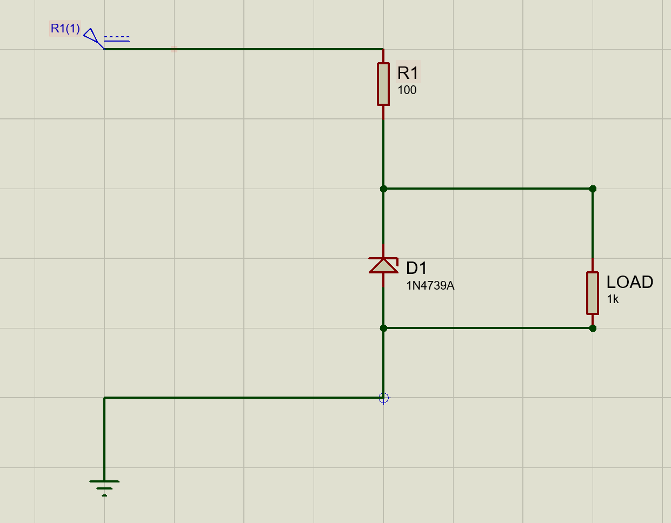

b.) Measure Vload, Iload, Izener, Imain for Vs values (5V, 8V, 9V, 10V, 15V) and record values to the table. (10 pt. = 20 * 0.5)

c.) What is the purpose of D1? Look carefully at your table before commenting. (10 pt.)

# Solution Question 1:

a.) Put your circuit design on Proteus using a print screen.

|  |
| --- |
| PUT YOUR DESIGNED CIRCUIT PRINT SCREEN |

b.) Measure Vload, Iload, Izener, Imain for Vs values (5V, 8V, 9V, 10V, 15V) and record values to the table below.

|  |  |  |  |  |  |
| --- | --- | --- | --- | --- | --- |
|  | | Vload | Iload | Izener | Imain |
| Vs | 5V |  |  |  |  |
| 8V |  |  |  |  |
| 9V |  |  |  |  |
| 10V |  |  |  |  |
| 15V |  |  |  |  |

c.) What is the purpose of D1? Look carefully to your table before commenting. No more than 4 sentences. Write down into below box:

|  |
| --- |
| Write your comment here. |

# Question No: 2:

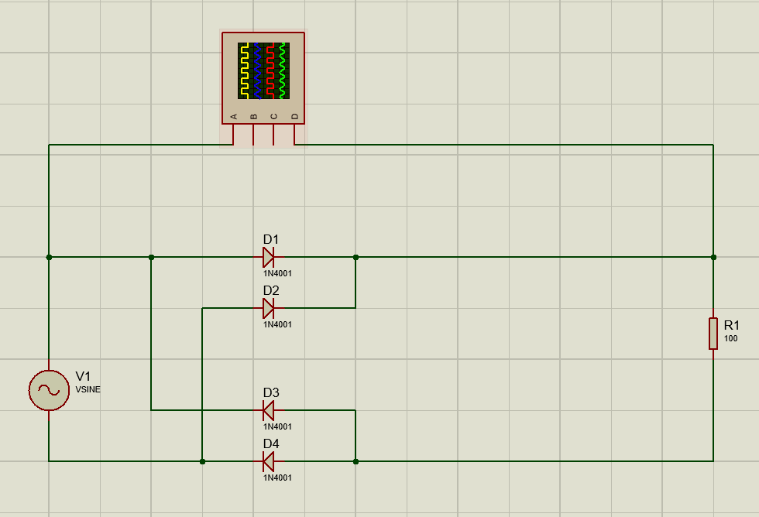

1. How did this circuit work? Explain current flows for positive and negative polarity. (10 pt.)
2. Draw the below circuit and analyze input/output (5 pt.)
   1. R1 = 100 Ohm
   2. V1 = 50V, 60Hz Sin wave
   3. 1N4001 Diodes
3. What is this circuit? (5 pt.)
4. We want to improve this circuit by smoothing the output so we get the output closer to DC characteristics.
   1. Add related **smoothing element** considering input amplitude to converge output signal to DC. (5 pt.)
   2. Observe your result; do you see ripple voltage?
      1. Show the ripples on the plot. (2.5 pt.)
      2. Try to eliminate ripple voltage as much as by **adjusting values** of elements except input voltages and diodes. (2.5 pt.)
   3. For further improvement; add a circuit element to completely eliminate the ripple voltage, then **regulate the signal to 24V** (-+0.7V accepted) (5 pt.)
5. (Bonus) What could be the potential danger of your final proposed circuit? How to solve that? (10 pt.)

# Solution Question 2:

1. How did this circuit work? Explain current flows for positive and negative polarity. You may put a print screen or your own drawing while telling details. Use the box below.

|  |
| --- |
| Your drawing or print screen or taken photo as you wish.  AND your comments on the circuit working structure go here. No more than 6 sentences. |

1. Using all 3 parameters; draw your circuit on the Proteus and run. Then take a print screen and put it below:

|  |
| --- |
| PUT YOUR UPDATED CIRCUIT PRINT SCREEN |

1. Name of this circuit very well-known in the literature:

|  |
| --- |
| Write the name here. |

* 1. After you have added the related element, put a print screen of the current version updated circuit below:

|  |
| --- |
| PUT YOUR DESIGNED CIRCUIT PRINT SCREEN |

* + 1. Show the ripples on the plot. Put the print screen below; after you marked the ripples on the PAINT program or sth. else.

|  |
| --- |
| PUT YOUR OUTPUT SIGNAL BY INDICATING THE RIPPLES |

* + 1. Try to eliminate ripple voltage as much as by **adjusting values** of elements except input voltages and diodes.

|  |
| --- |
| PUT BOTH YOUR CIRCUIT WITH ADJUSTED ELEMENTS AND THE RELATED OUTPUT SIGNAL. |

* 1. After you have added an element and adjusted the signal as required, put the updated circuit and the related output below:

|  |
| --- |
| PUT BOTH YOUR CIRCUIT AND THE RELATED OUTPUT SIGNAL. |

1. (Bonus) What could be the potential danger of your final proposed circuit? How to solve that?

|  |
| --- |
| Write your comments here.  The danger: (No more than 2 sentences)  The solution: (No more than 3 sentences) |

# Question No: 3:

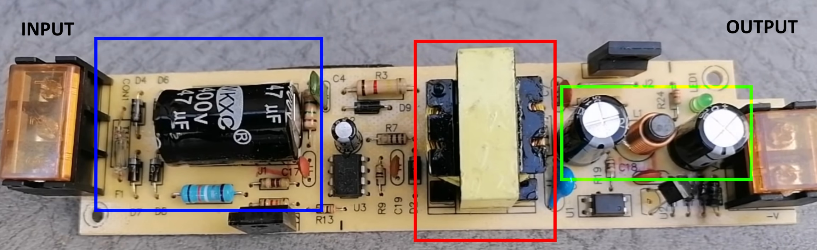

1. Which circuit elements do you see in blue, red and green rectangles? (9 pt.)
2. What could be the blue area doing? (6 pt.)
3. Predict input & output signal types and amplitudes related to each other. (5pt.)
4. What could this entire circuit be doing according to your prior findings? (5 pt.)

# Solution Question 3:

1. Which circuit elements do you see in blue, red and green rectangles? Write down the answers in the box below.

|  |
| --- |
| Blue:  Red:  Red: |

1. What could be the blue area doing? Write down the answers into the box below.

|  |
| --- |
| The Blue is doing: |

1. Predict input & output signal types and amplitudes related to each other. Write down the answers into the box below.

|  |
| --- |
| Write answer comment here. |

1. What could this entire circuit be doing according to your prior findings? Write down the answers into the box below.

|  |
| --- |
| Write answer comment here. |